Distance Equality
# Source: AI Source: Provided by: [Data Path: Persons Table -> ID Column: 1, Name_En Column: Motasem Essam] -> From: [ChatGPT] on [7/25/2026]
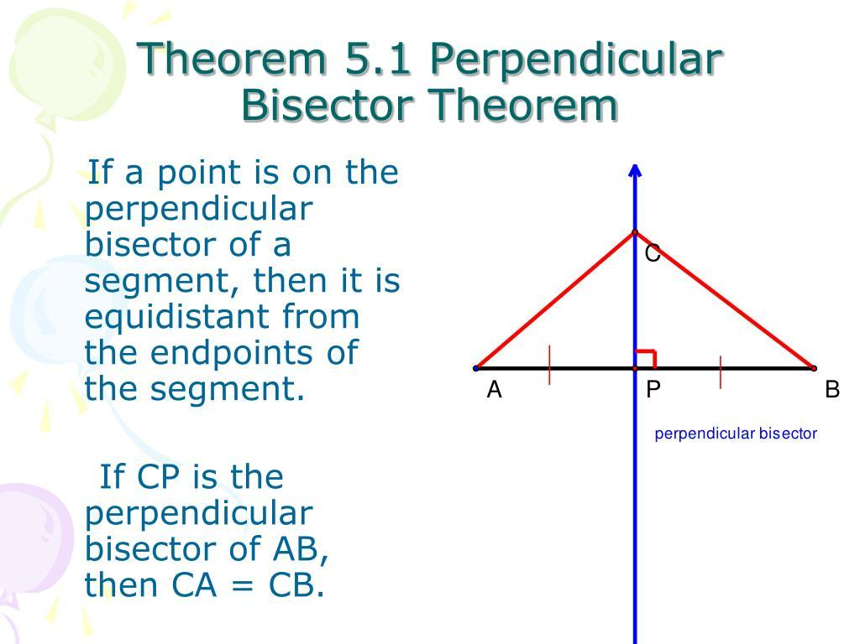
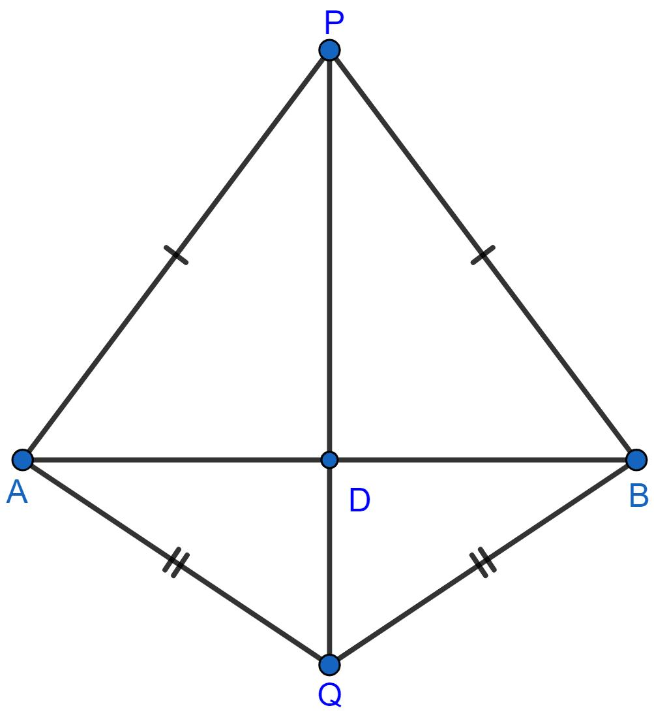
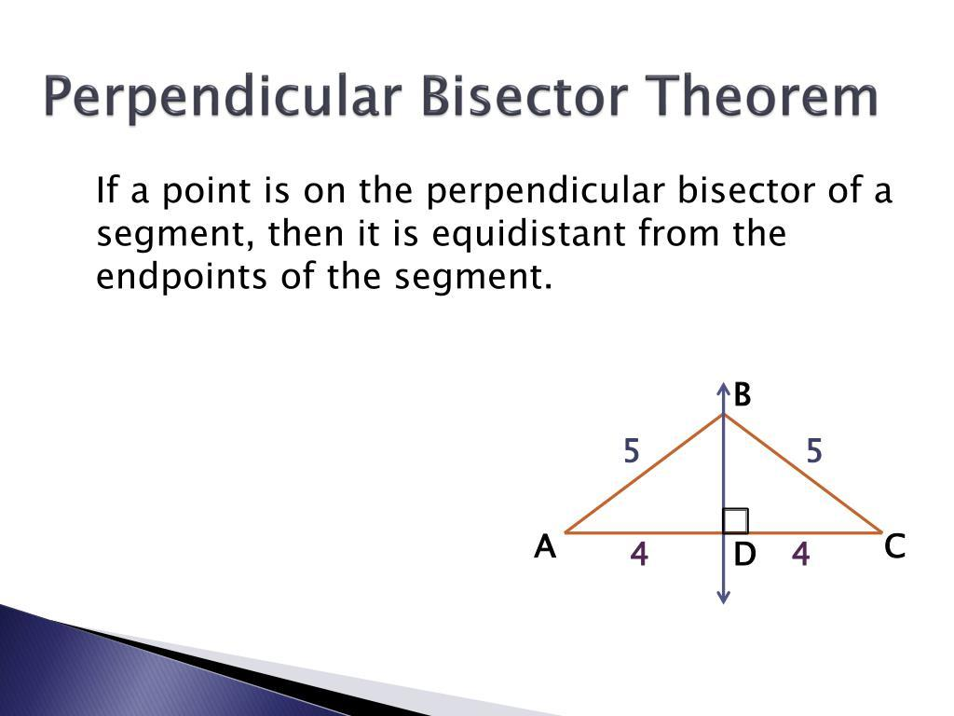
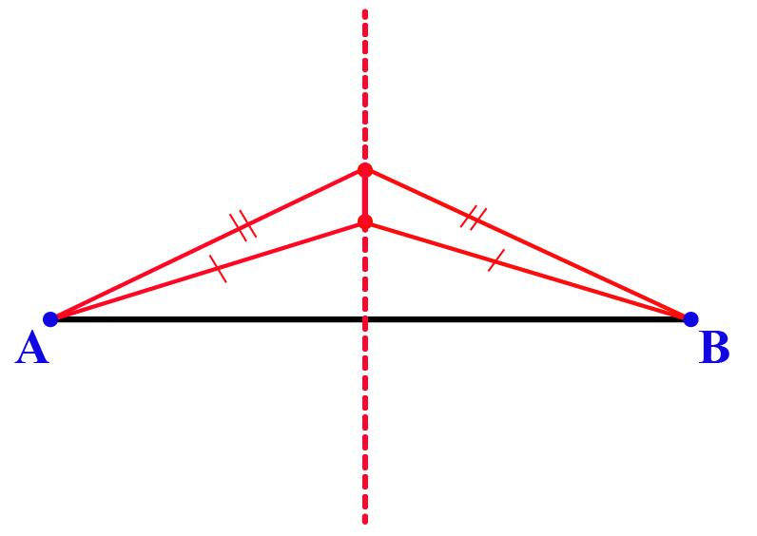
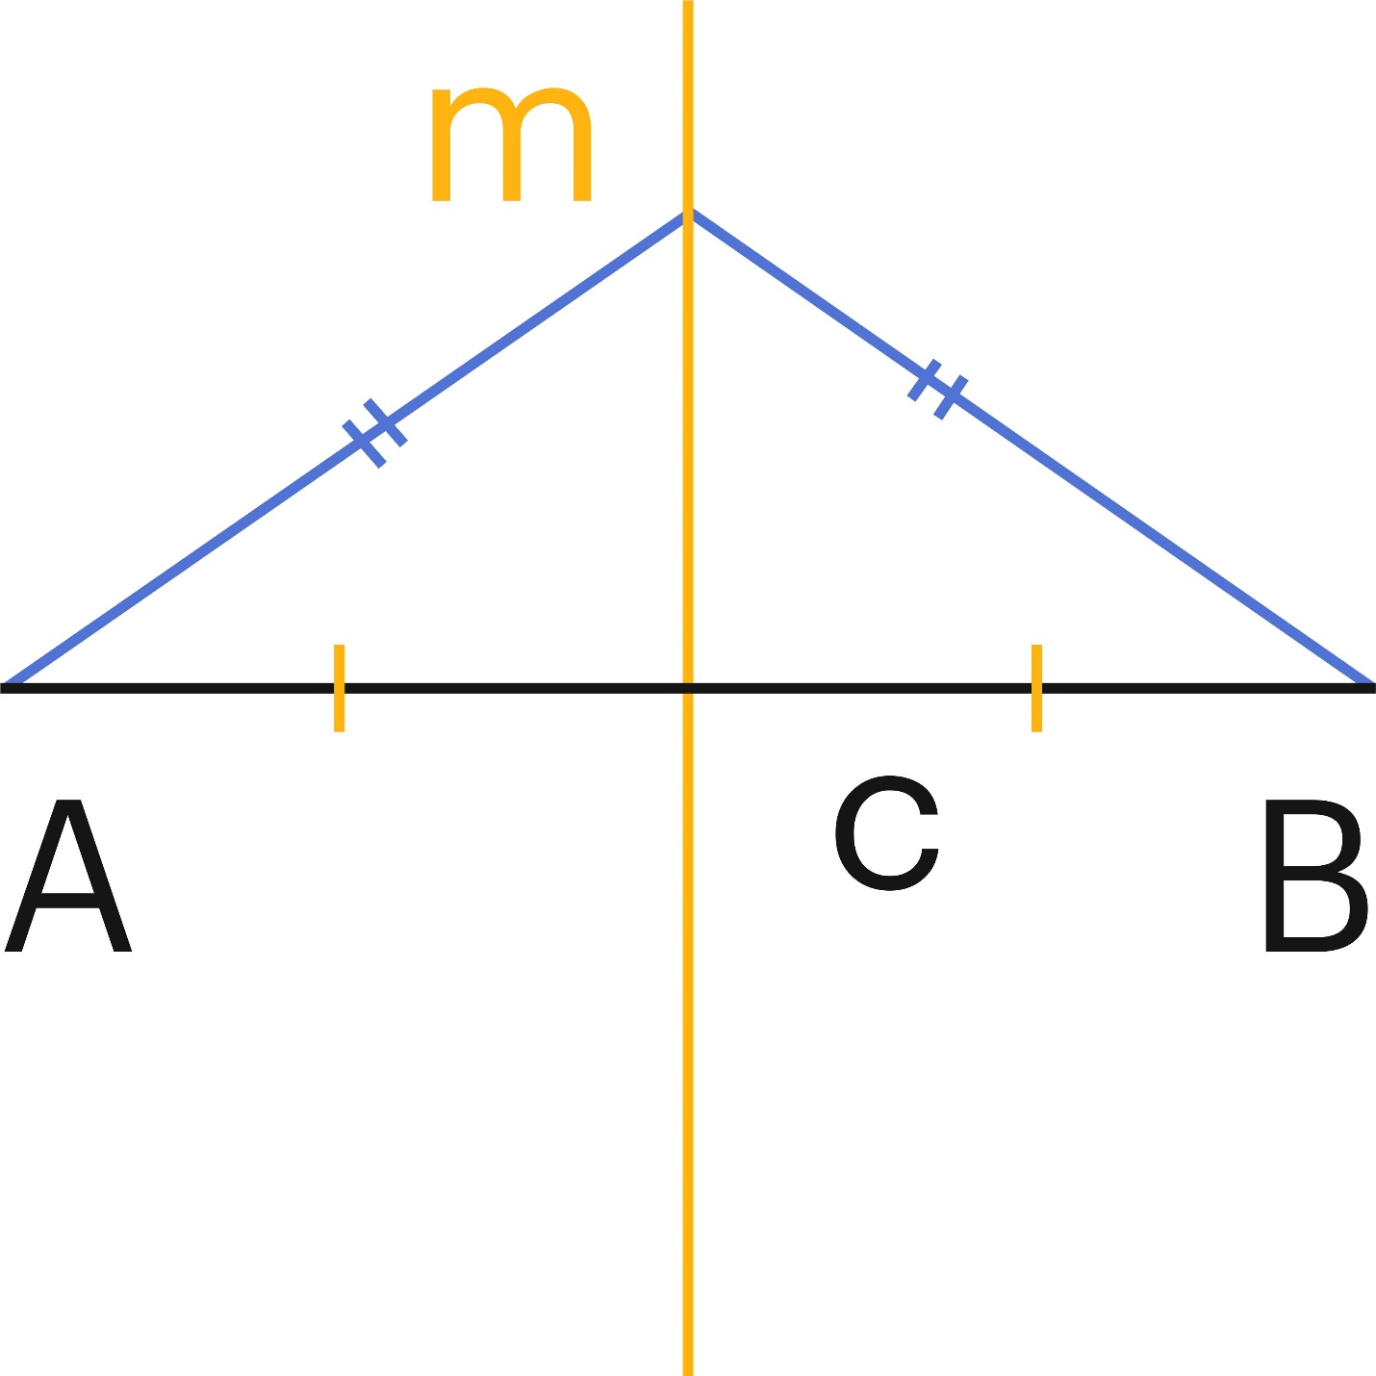

Definition
# Source: AI Source: Provided by: [Data Path: Persons Table -> ID Column: 1, Name_En Column: Motasem Essam] -> From: [ChatGPT] on [7/25/2026]
Distance Equality is an exact geometric relationship in which two or more distances are equal.
It is represented by:
$$\boxed{PA=PB}$$
where $PA$and $PB$represent the distances from point $P$to points $A$and $B$.
Distance equality can compare:
- point-to-point distances,
- point-to-line distances,
- point-to-circle distances,
- distances between parallel lines,
- radii,
- geometric distances calculated from coordinates.

Simple Definition
# Source: AI Source: Provided by: [Data Path: Persons Table -> ID Column: 1, Name_En Column: Motasem Essam] -> From: [ChatGPT] on [7/25/2026]
Distance Equality means that two or more geometric distances have exactly the same value.
Example:
$$PA=PB=5\text{ cm}$$
Therefore, $P$is equally distant from $A$and $B$.

Fundamental Concept
# Source: AI Source: Provided by: [Data Path: Persons Table -> ID Column: 1, Name_En Column: Motasem Essam] -> From: [ChatGPT] on [7/25/2026]
Distance equality compares lengths measured between geometric objects.
For example:
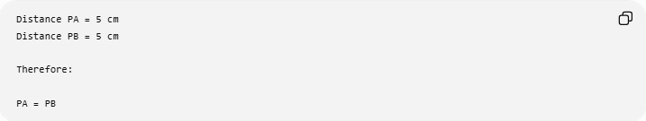
Distance PA = 5 cm
Distance PB = 5 cm

Therefore:

PA = PB
The objects being measured do not need to be in the same direction.
$$\boxed{\text{Equal distances}=\text{Equal numerical measurements}}$$

Types of Distance Equality
# Source: AI Source: Provided by: [Data Path: Persons Table -> ID Column: 1, Name_En Column: Motasem Essam] -> From: [ChatGPT] on [7/25/2026]
The following is a practical classification of common ways distance equality occurs in geometry.
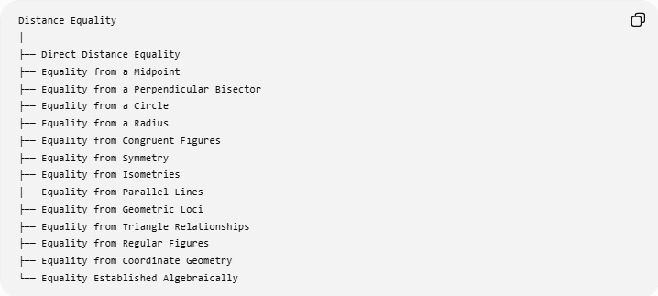
Distance Equality
│
├── Direct Distance Equality
├── Equality from a Midpoint
├── Equality from a Perpendicular Bisector
├── Equality from a Circle
├── Equality from a Radius
├── Equality from Congruent Figures
├── Equality from Symmetry
├── Equality from Isometries
├── Equality from Parallel Lines
├── Equality from Geometric Loci
├── Equality from Triangle Relationships
├── Equality from Regular Figures
├── Equality from Coordinate Geometry
└── Equality Established Algebraically

Direct Distance Equality
# Source: AI Source: Provided by: [Data Path: Persons Table -> ID Column: 1, Name_En Column: Motasem Essam] -> From: [ChatGPT] on [7/25/2026]
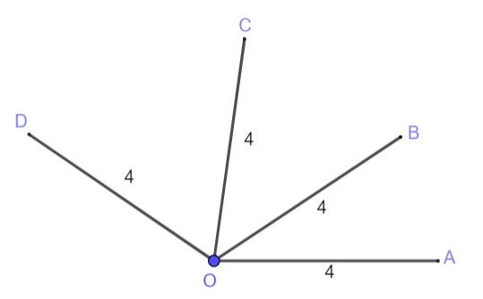
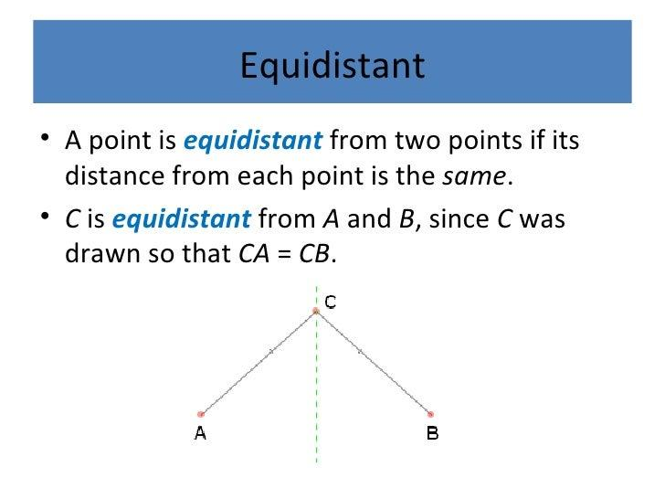
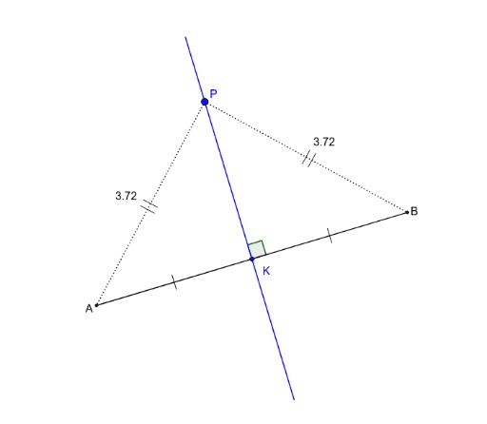
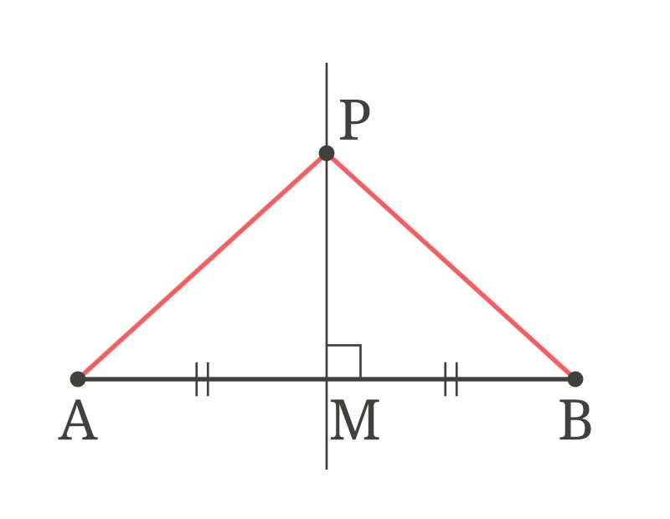
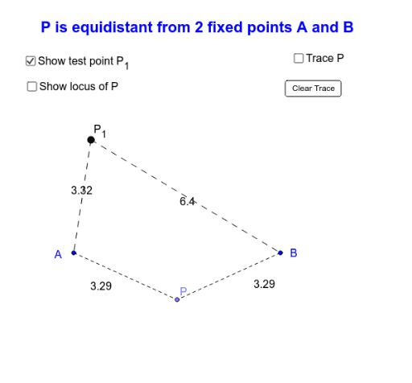
Definition
Distance equality may be given directly as known information.
$$\boxed{PA=PB}$$
Example
Suppose:
$$PA=7\text{ cm}$$
and:
$$PB=7\text{ cm}$$
Therefore:
$$\boxed{PA=PB}$$
Point $P$is equally distant from $A$and $B$.

Equality from a Midpoint
# Source: AI Source: Provided by: [Data Path: Persons Table -> ID Column: 1, Name_En Column: Motasem Essam] -> From: [ChatGPT] on [7/25/2026]
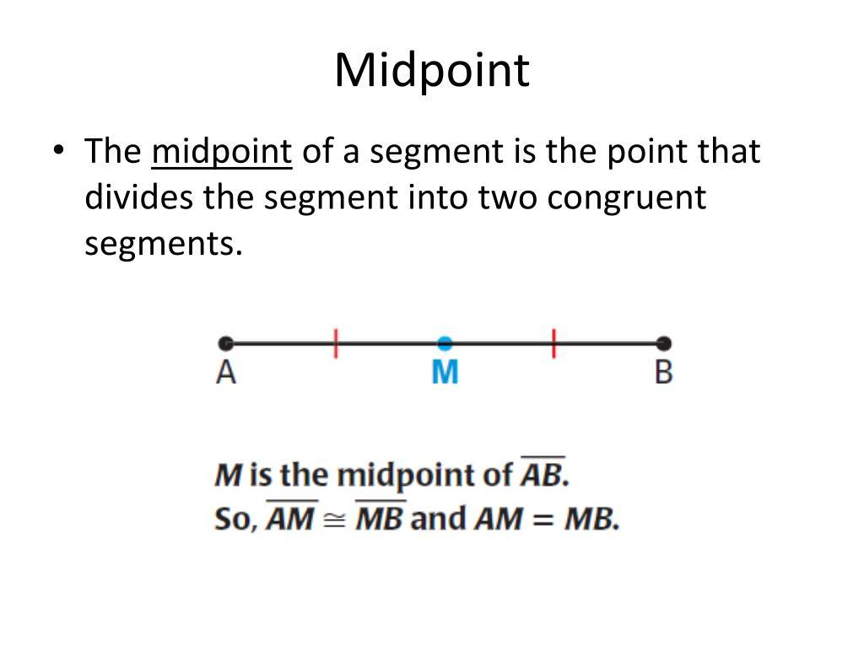
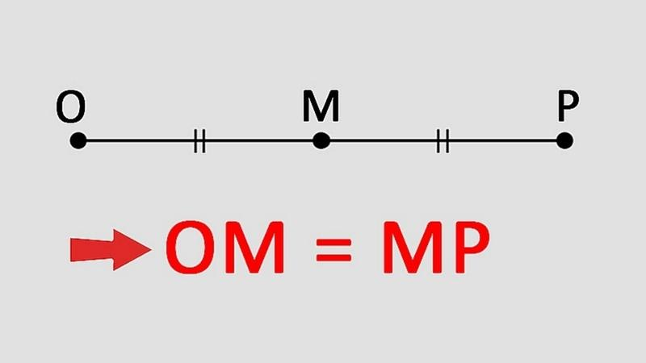
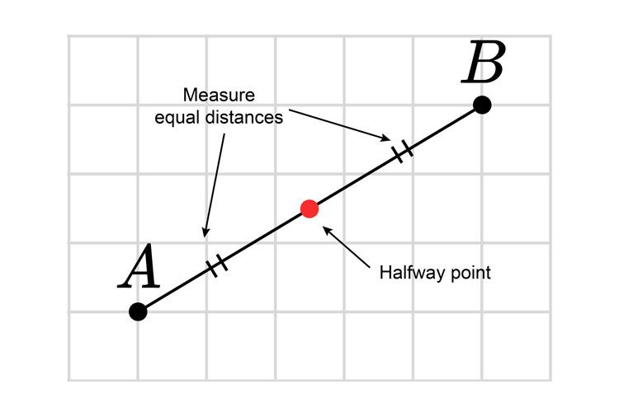
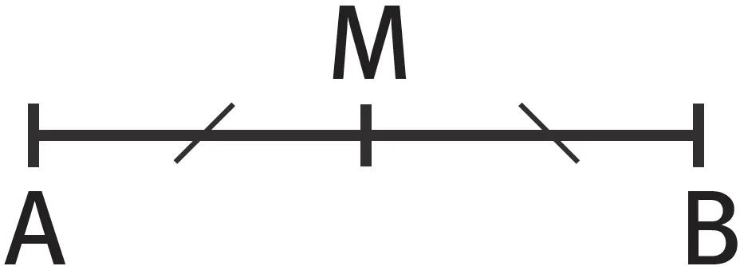
Definition
A midpoint divides a segment into two equal lengths.
If $M$is the midpoint of $\overset{‾}{AB}$, then:
$$\boxed{AM=MB}$$
Example
If:
$$AB=12\text{ cm}$$
and $M$is its midpoint, then:
$$AM=MB=\frac{12}{2} \\ \boxed{AM=MB=6\text{ cm}}$$
Key Relationship
$$\boxed{\text{Midpoint}→\text{Equal Distances from the Endpoints}}$$

Equality from a Perpendicular Bisector
# Source: AI Source: Provided by: [Data Path: Persons Table -> ID Column: 1, Name_En Column: Motasem Essam] -> From: [ChatGPT] on [7/25/2026]
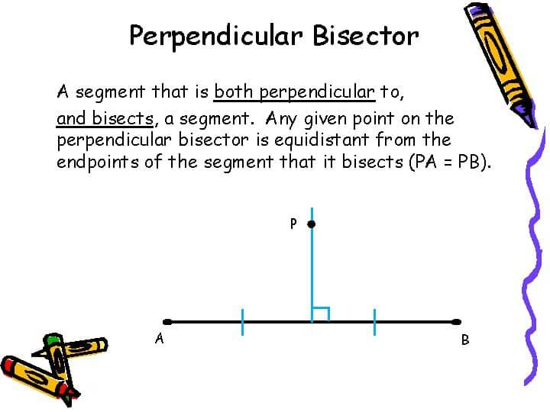
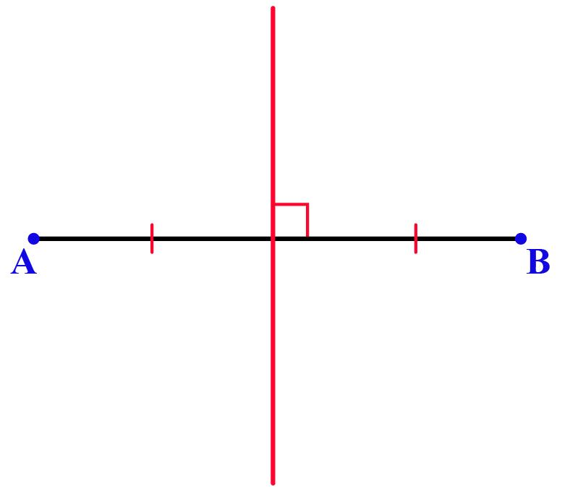
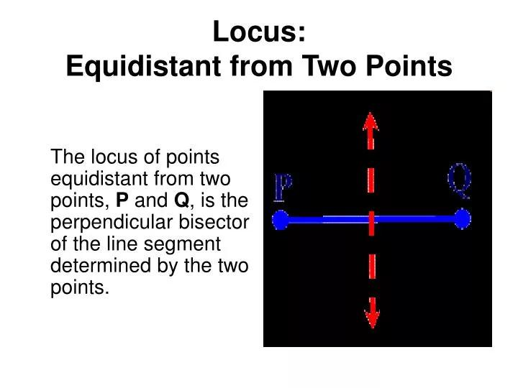
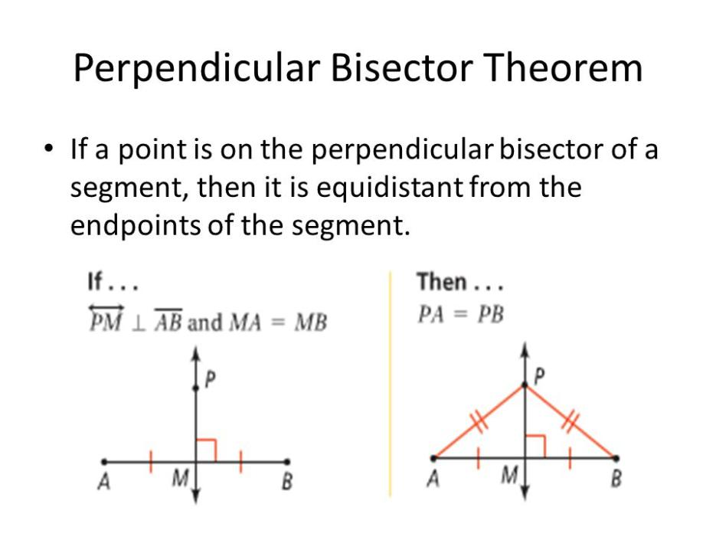
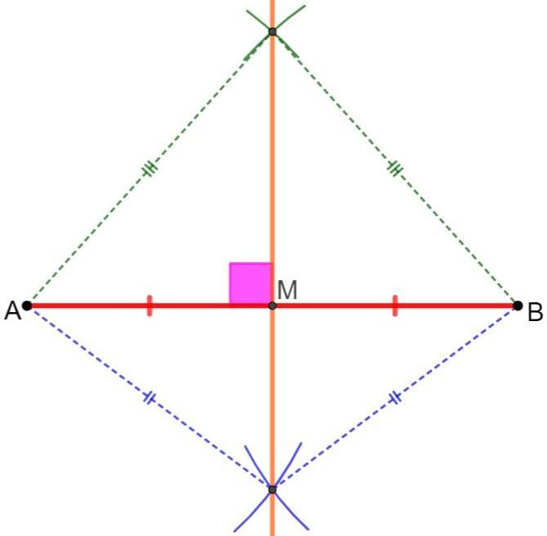
The perpendicular bisector of a segment has a fundamental distance property.
If $P$lies on the perpendicular bisector of $\overset{‾}{AB}$, then:
$$\boxed{PA=PB}$$
Example
Let $M$be the midpoint of $AB$, and let $PM⊥AB$.
Then:
$$AM=MB$$
and:
$$PM⊥AB$$
Any point $P$on this perpendicular bisector satisfies:
$$\boxed{PA=PB}$$
Converse
If:
$$\boxed{PA=PB}$$
then $P$lies on the perpendicular bisector of $\overset{‾}{AB}$.
Thus:
$$\boxed{PA=PB ⟺ P\text{ lies on the perpendicular bisector of }AB}$$
This is one of the most important distance loci in geometry.

Equality from a Circle
# Source: AI Source: Provided by: [Data Path: Persons Table -> ID Column: 1, Name_En Column: Motasem Essam] -> From: [ChatGPT] on [7/25/2026]
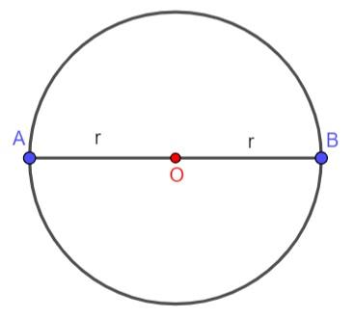
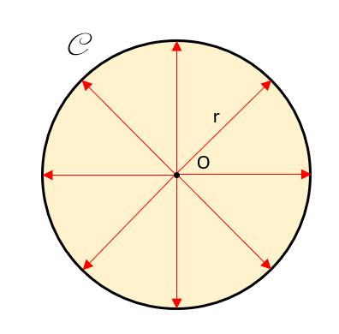
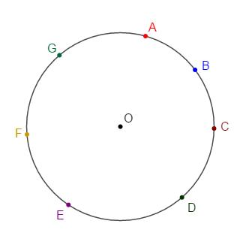
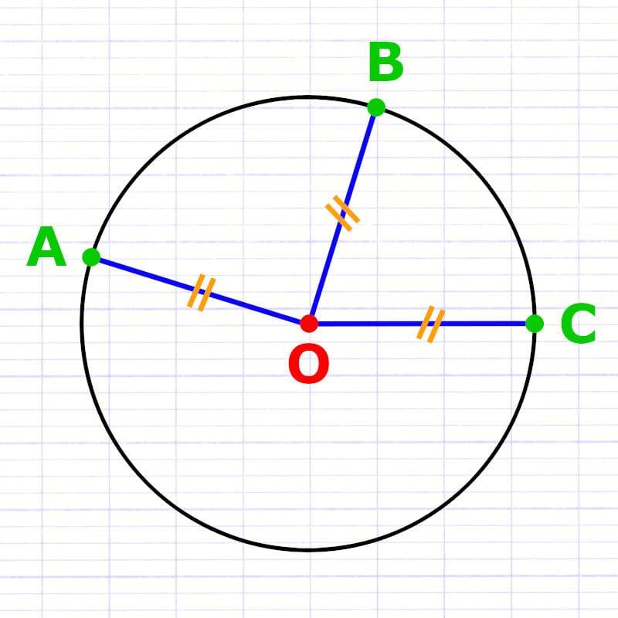
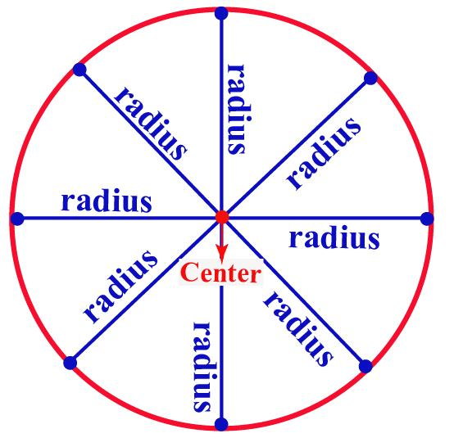
Every point on a circle is the same distance from the center.
If $O$is the center and $A,B,C$lie on the circle:
$$\boxed{OA=OB=OC=r}$$
where $r$is the radius.
Example
For a circle with radius $5$cm:
$$OA=OB=OC=5\text{ cm}$$
Therefore:
$$\boxed{OA=OB=OC}$$
Key Relationship
$$\boxed{\text{Circle}→\text{Equal Distance from Center}}$$

Equality from a Radius
# Source: AI Source: Provided by: [Data Path: Persons Table -> ID Column: 1, Name_En Column: Motasem Essam] -> From: [ChatGPT] on [7/25/2026]
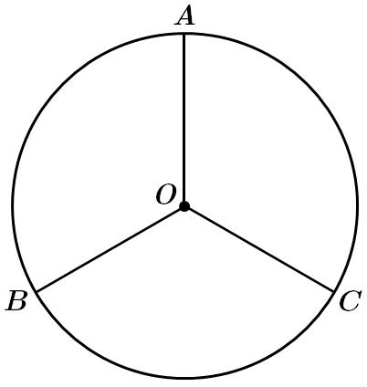
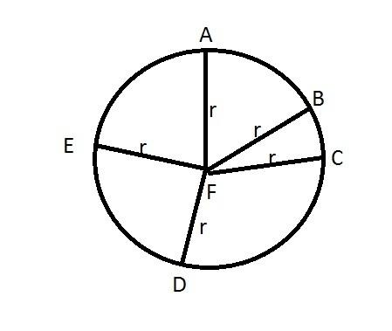
All radii of the same circle are equal.
If $O$is the center:
$$\boxed{OA=OB=OC=OD}$$
provided $A,B,C,D$are points on the circle.
Example
If:
$$OA=8\text{ cm}$$
then every radius of the same circle is:
$$\boxed{8\text{ cm}}$$

Equality from Congruent Figures
# Source: AI Source: Provided by: [Data Path: Persons Table -> ID Column: 1, Name_En Column: Motasem Essam] -> From: [ChatGPT] on [7/25/2026]
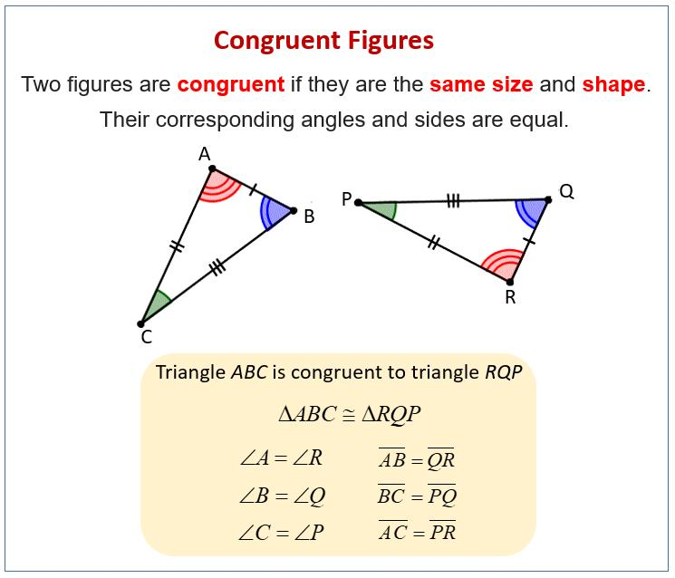
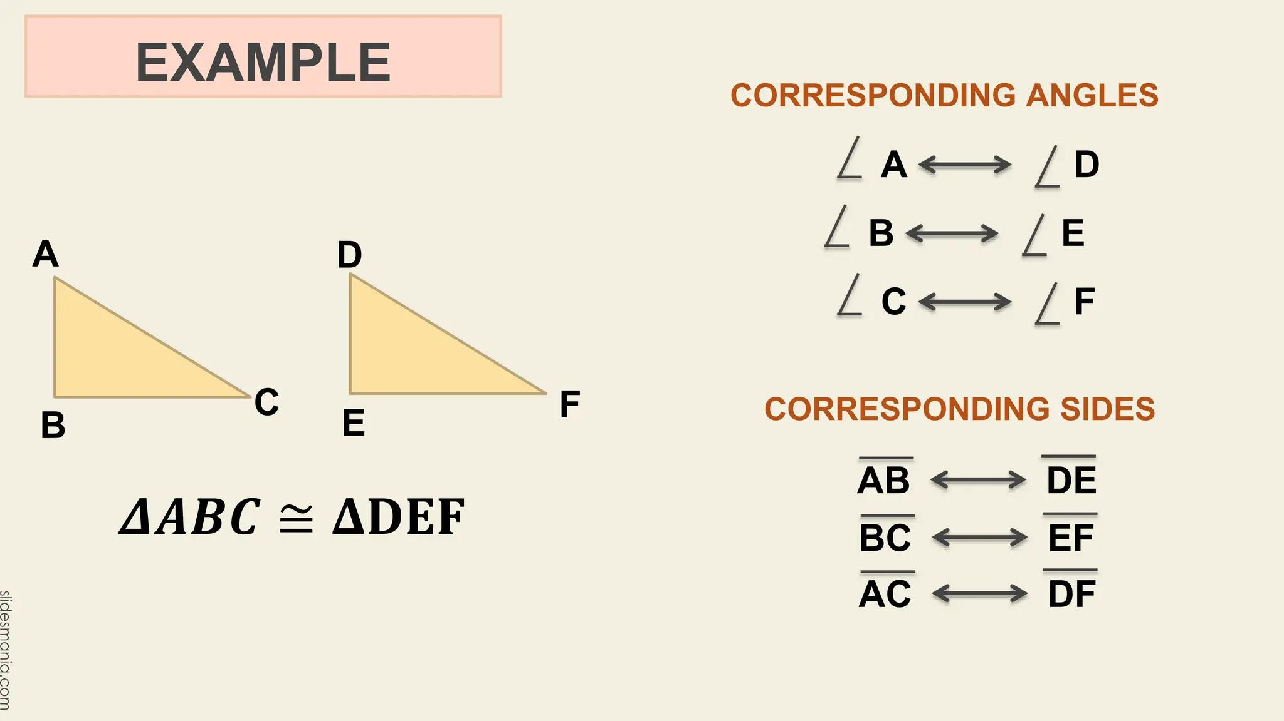
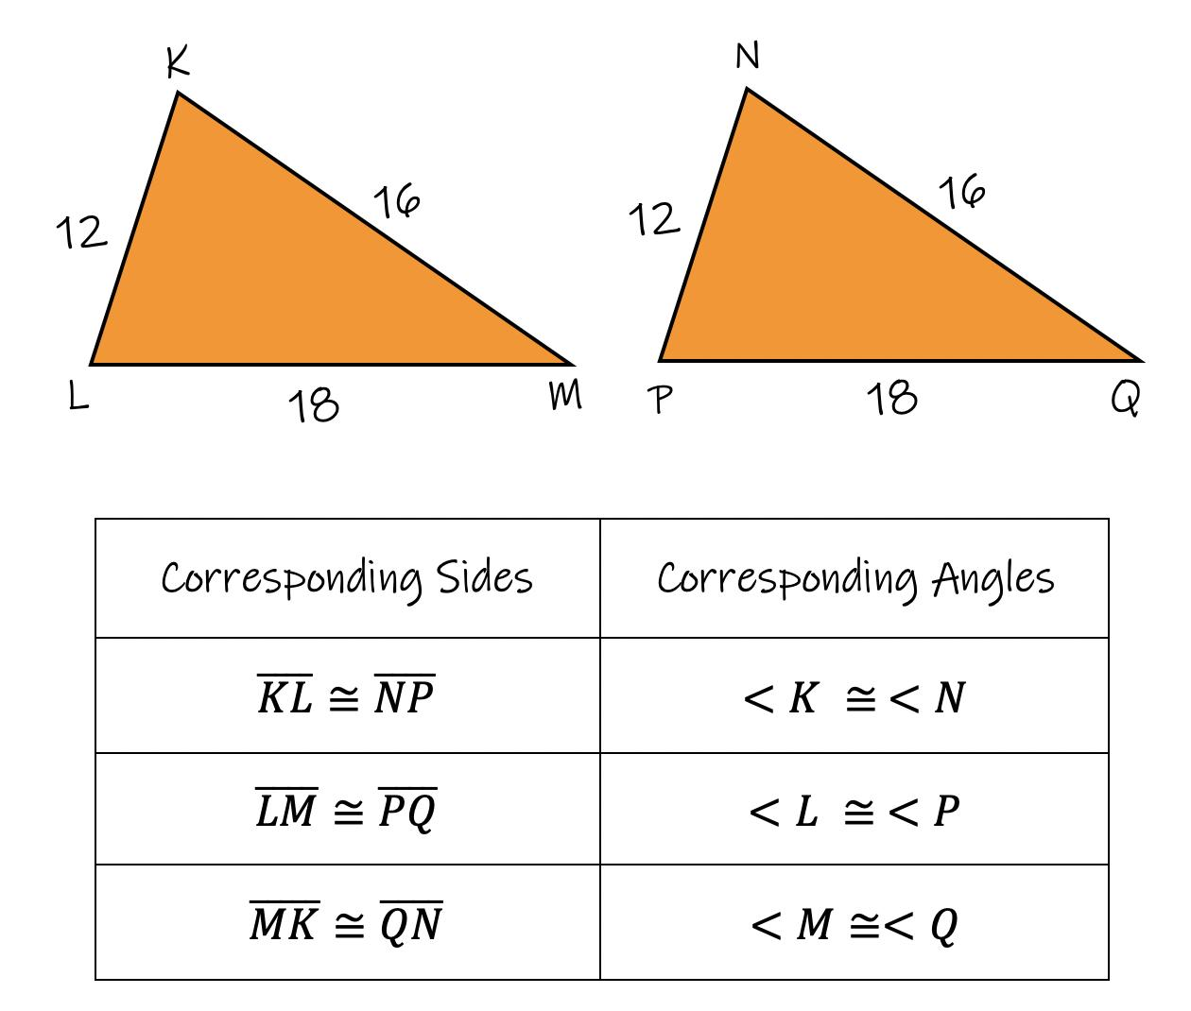
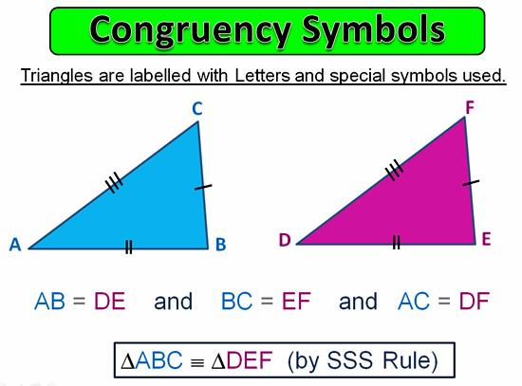
Congruent figures have corresponding lengths equal.
If:
$$△ABC≅△DEF$$
then:
$$\boxed{AB=DE} \\ \boxed{BC=EF} \\ \boxed{AC=DF}$$
Example
If two triangles are congruent and:
$$AB=9\text{ cm}$$
then the corresponding side satisfies:
$$\boxed{DE=9\text{ cm}}$$
This follows from CPCTC.

Equality from Symmetry
# Source: AI Source: Provided by: [Data Path: Persons Table -> ID Column: 1, Name_En Column: Motasem Essam] -> From: [ChatGPT] on [7/25/2026]
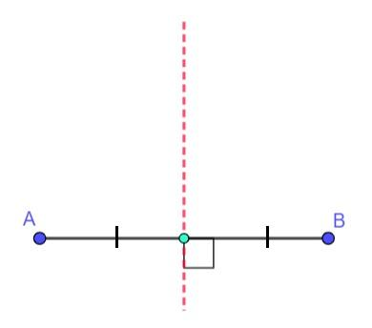
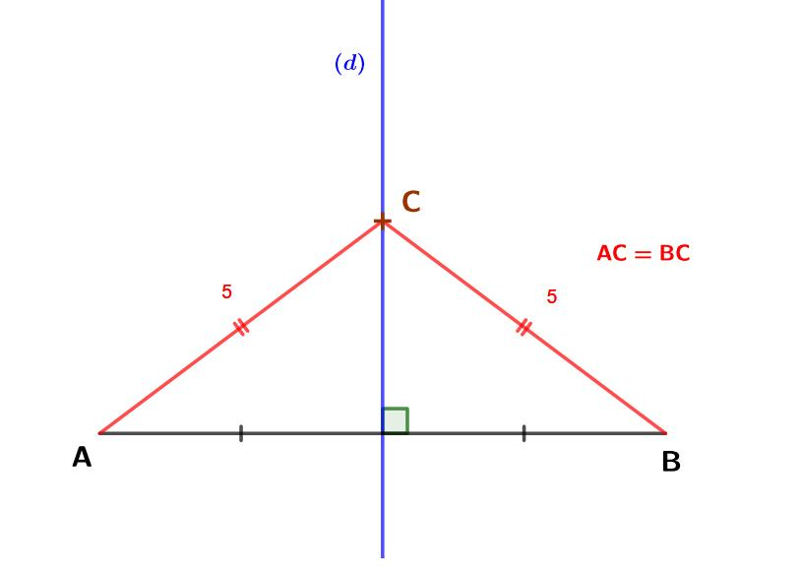
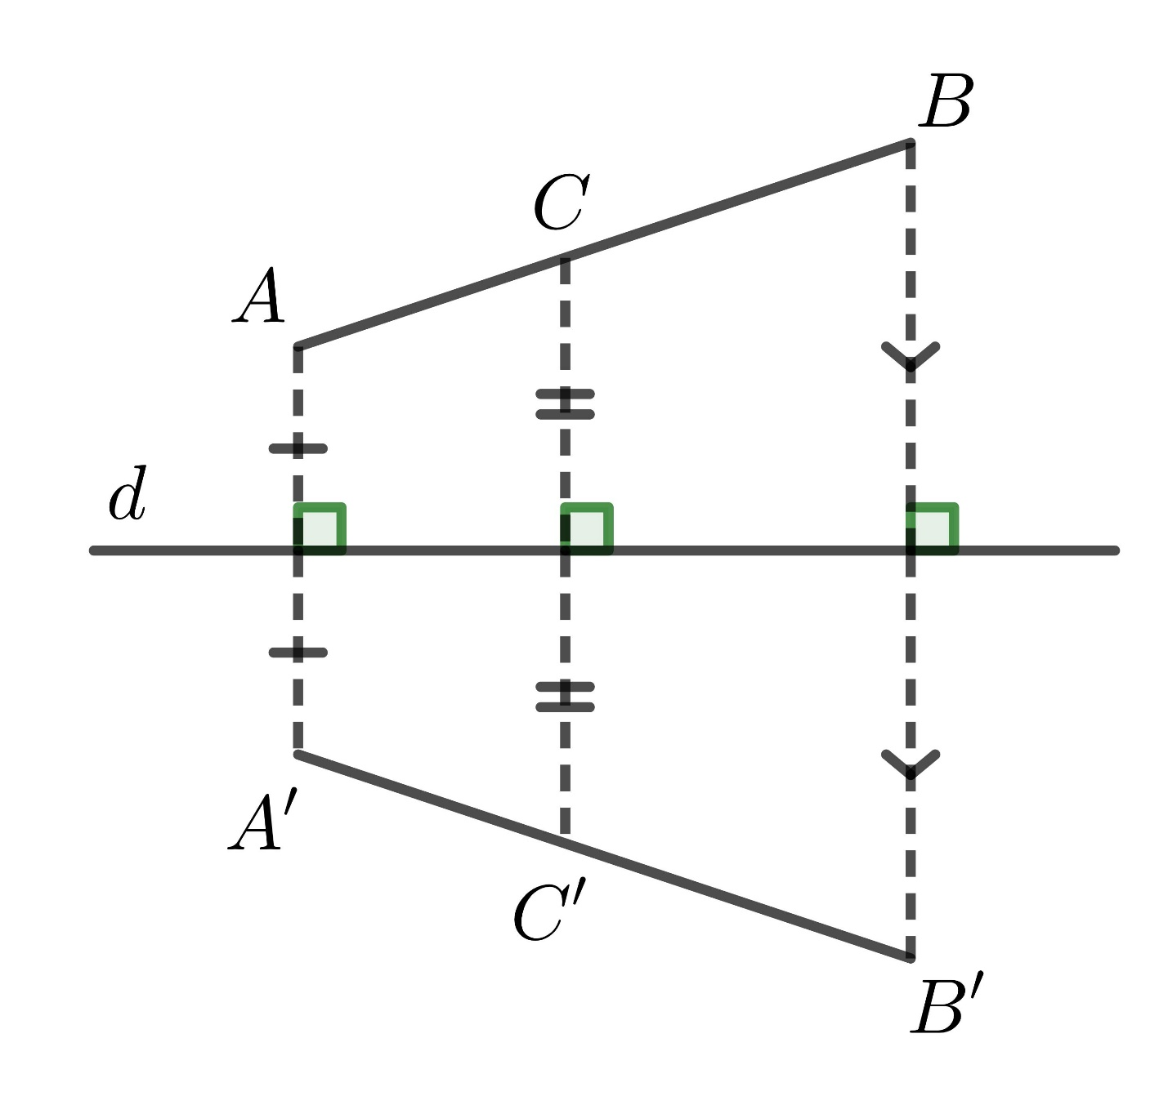
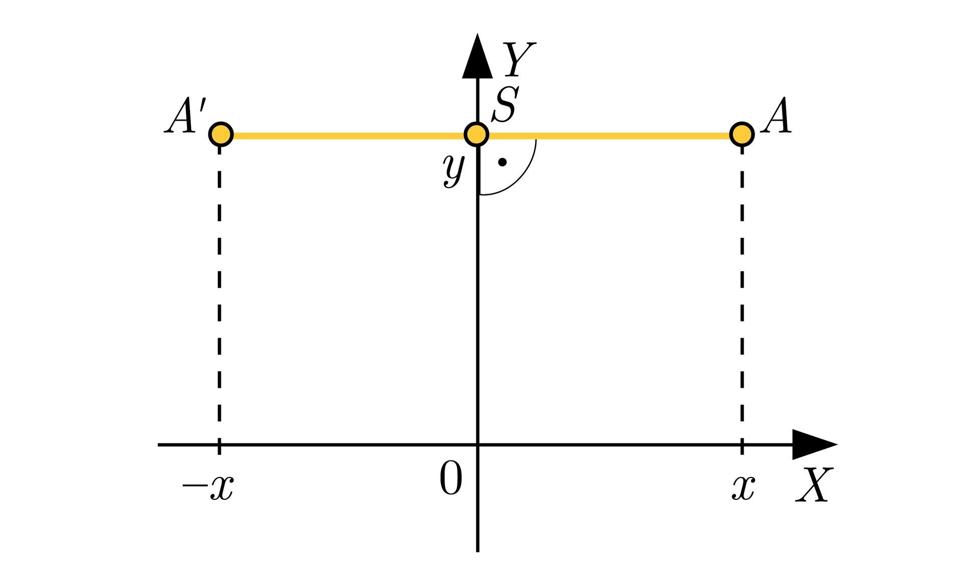
Symmetry can produce equal distances because corresponding points under a symmetry transformation preserve distance.
Example
Suppose a figure is symmetric about line $l$.
If points $A$and $B$are mirror images across $l$, then every point $P$on the symmetry axis satisfies:
$$\boxed{PA=PB}$$
Key Idea
The symmetry axis acts as the perpendicular bisector of the segment joining corresponding reflected points.

Equality from Isometries
# Source: AI Source: Provided by: [Data Path: Persons Table -> ID Column: 1, Name_En Column: Motasem Essam] -> From: [ChatGPT] on [7/25/2026]
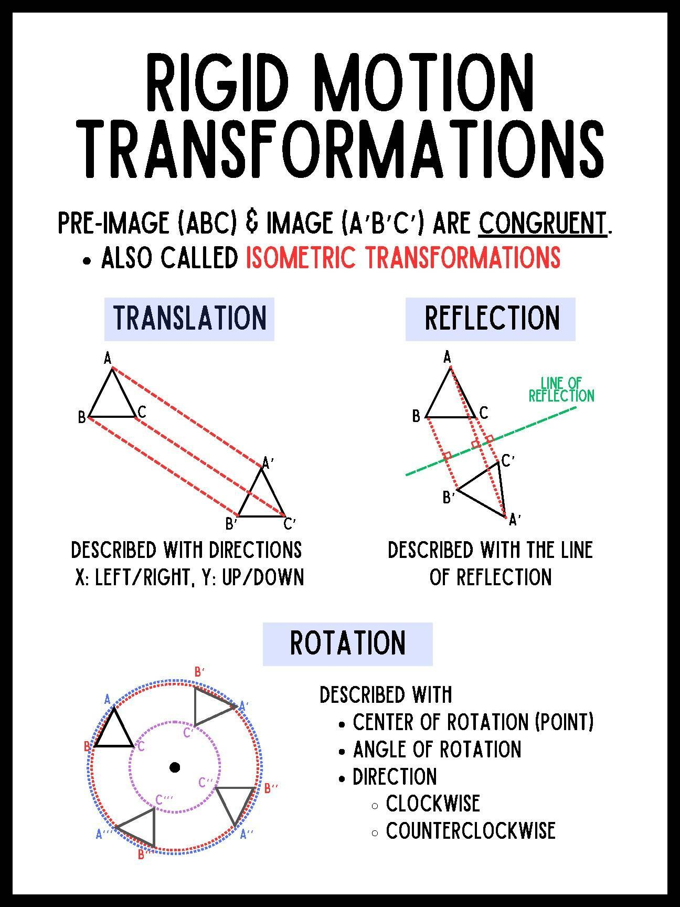
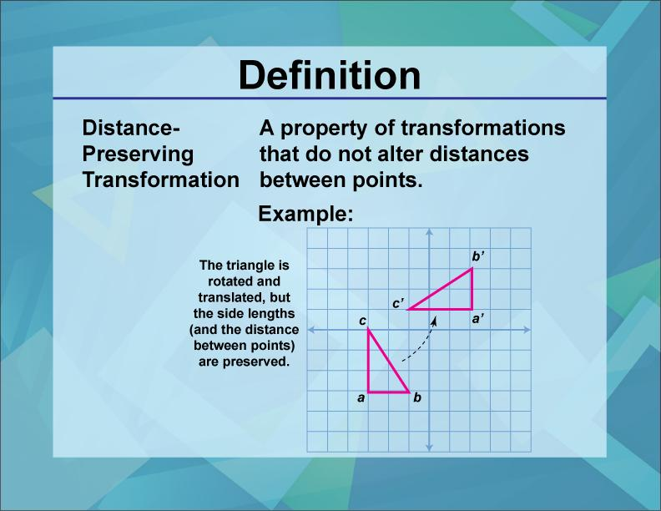
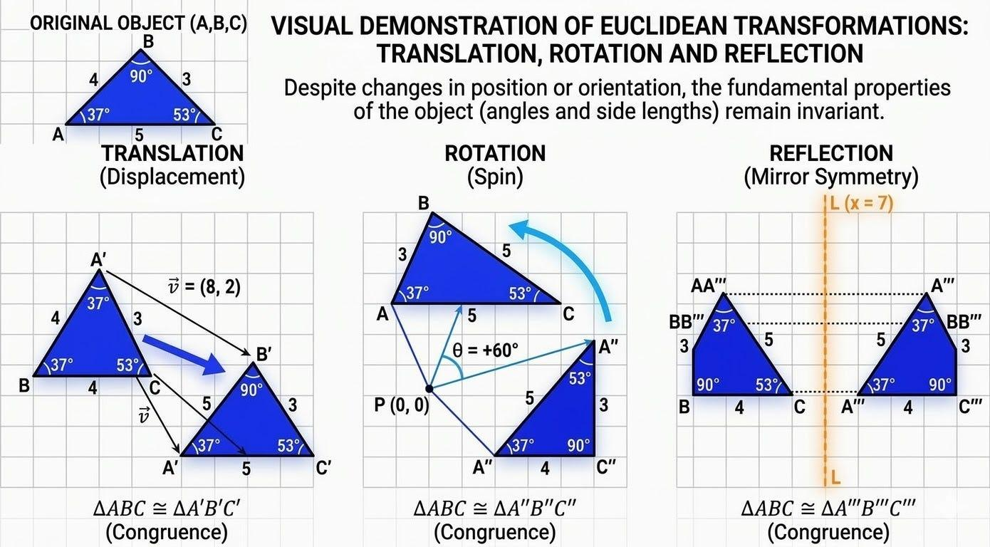
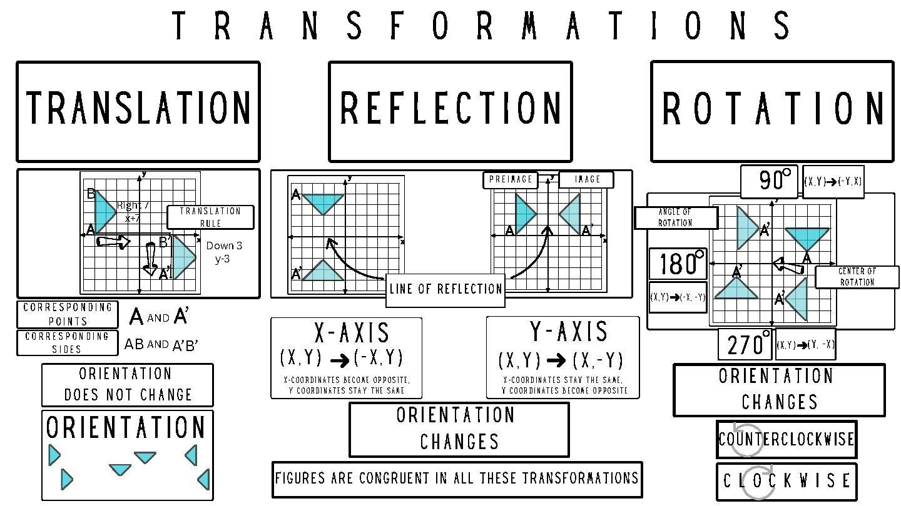
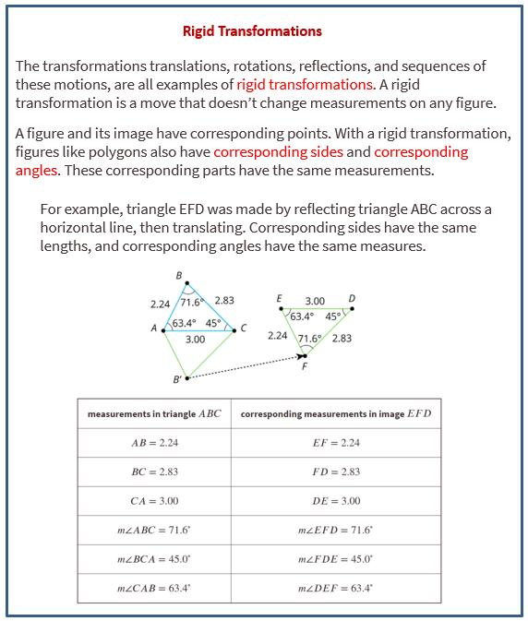
An isometry is a transformation that preserves distances.
Important isometries include:
- Translation
- Rotation
- Reflection
- Glide reflection
If points $A,B$are transformed into $A^{'},B^{'}$, then:
$$\boxed{AB=A^{'}B^{'}}$$
Example
Suppose:
$$AB=6\text{ cm}$$
After a rotation:
$$A→A^{'}, B→B^{'}$$
Then:
$$\boxed{A^{'}B^{'}=6\text{ cm}}$$
Therefore:
$$\boxed{AB=A^{'}B^{'}}$$

Equality from Parallel Lines
# Source: AI Source: Provided by: [Data Path: Persons Table -> ID Column: 1, Name_En Column: Motasem Essam] -> From: [ChatGPT] on [7/25/2026]
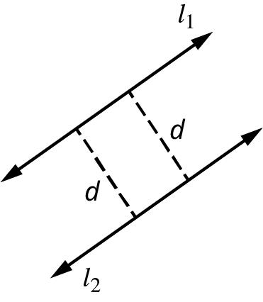
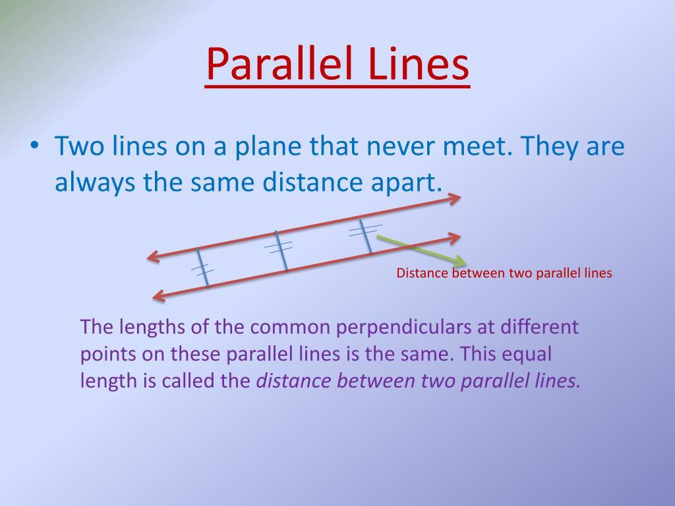
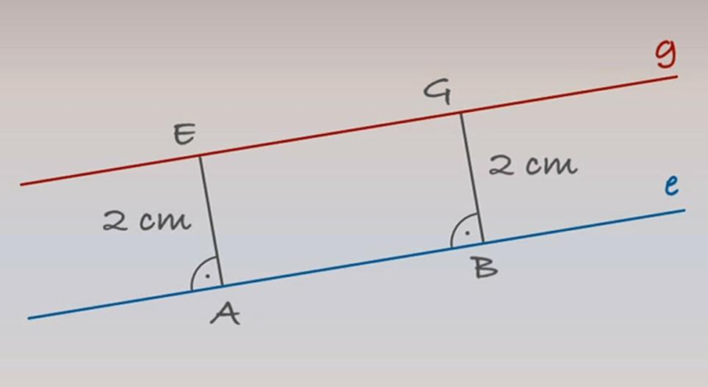
Two parallel lines have a constant perpendicular distance between them.
If:
$$l_{1}∥l_{2}$$
and $AB$and $CD$are perpendicular segments connecting the two lines, then:
$$\boxed{AB=CD}$$
provided both are measured perpendicularly between the same parallel lines.
Example
If the perpendicular distance between two parallel lines is:
$$5\text{ cm}$$
then every perpendicular segment connecting the lines has length:
$$\boxed{5\text{ cm}}$$
Important
The equality applies to the perpendicular distance, not arbitrary slanted segments between the parallel lines.

Equality from Geometric Loci
# Source: AI Source: Provided by: [Data Path: Persons Table -> ID Column: 1, Name_En Column: Motasem Essam] -> From: [ChatGPT] on [7/25/2026]
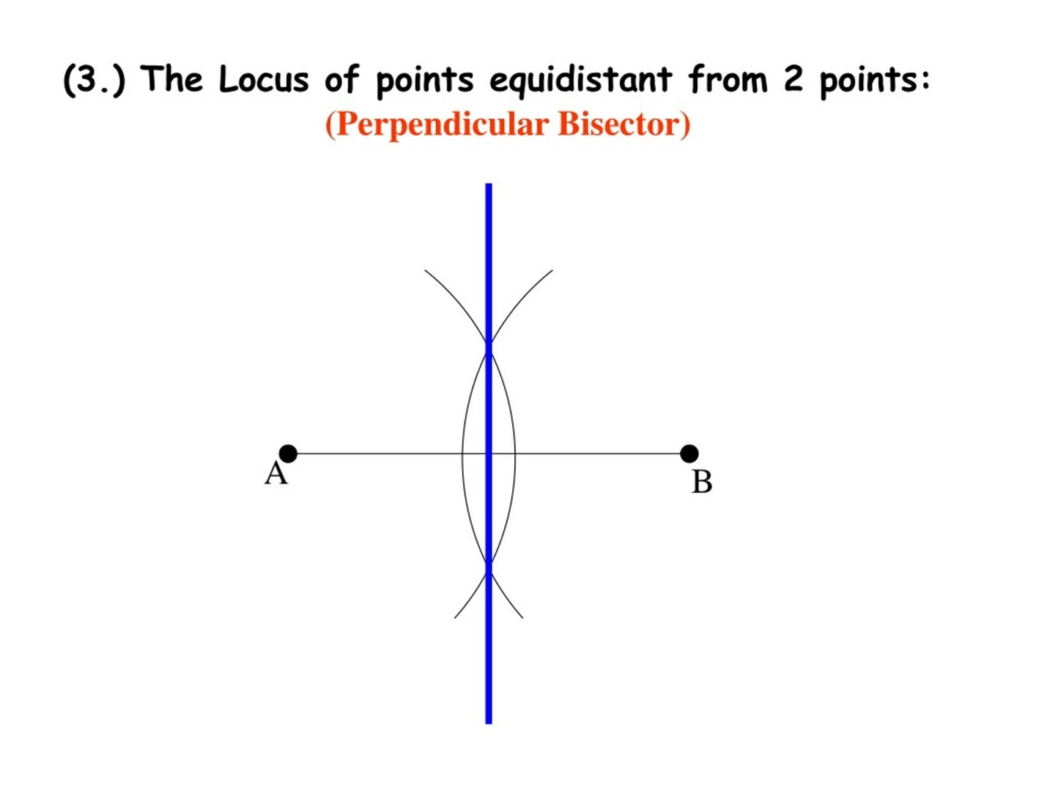
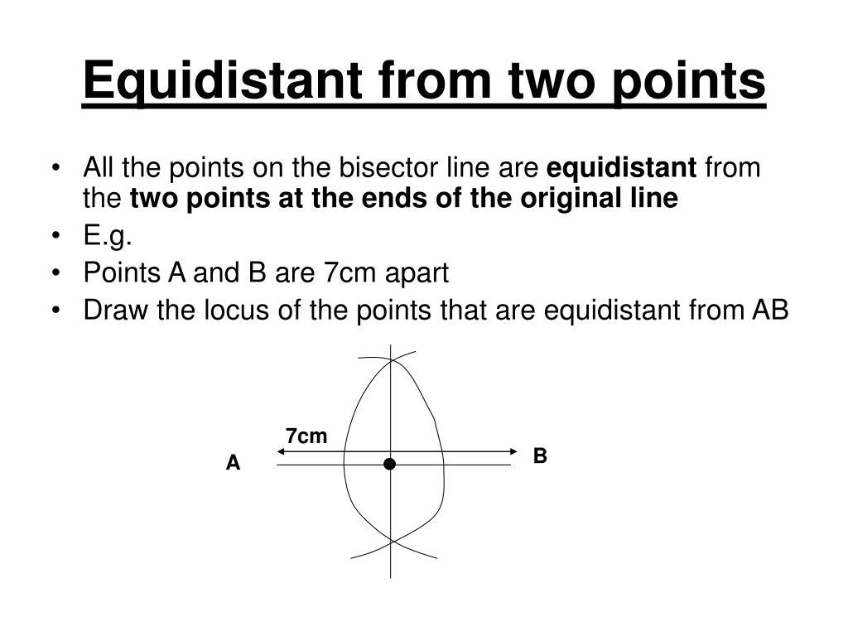
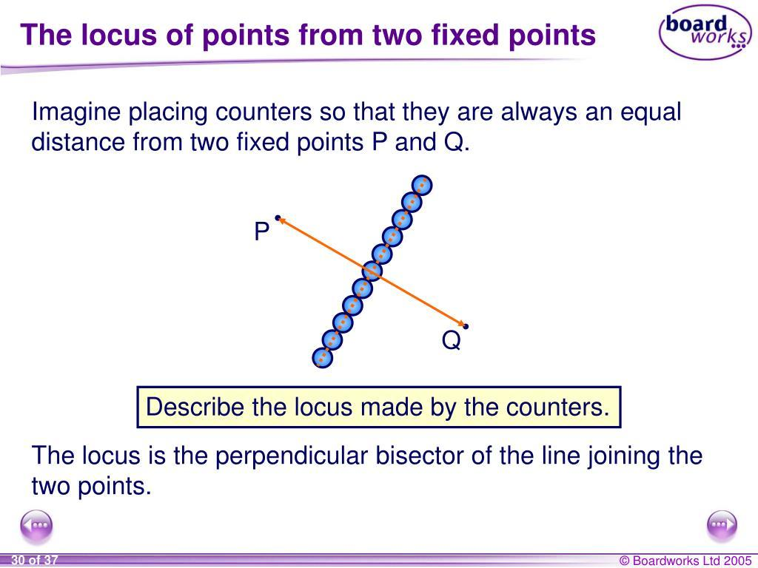
A locus can describe all points satisfying an equal-distance condition.
For two fixed points $A$and $B$:
$$\boxed{PA=PB}$$
describes the perpendicular bisector of $AB$.
Example
If:
$$PA=PB$$
then $P$belongs to the locus:
$$\boxed{\text{Perpendicular Bisector of }AB}$$
This creates the important relationship:
$$\boxed{\text{Distance Equality}↔\text{Locus}}$$

Equality from Triangle Relationships
# Source: AI Source: Provided by: [Data Path: Persons Table -> ID Column: 1, Name_En Column: Motasem Essam] -> From: [ChatGPT] on [7/25/2026]
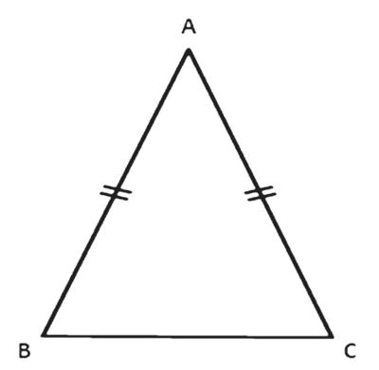
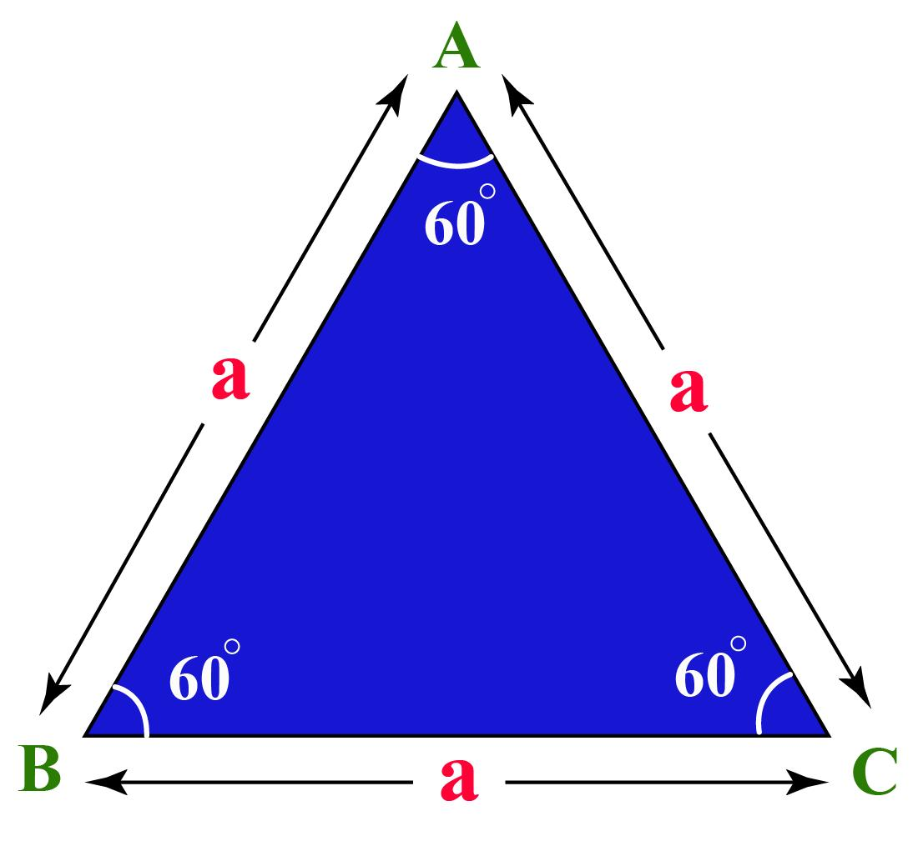
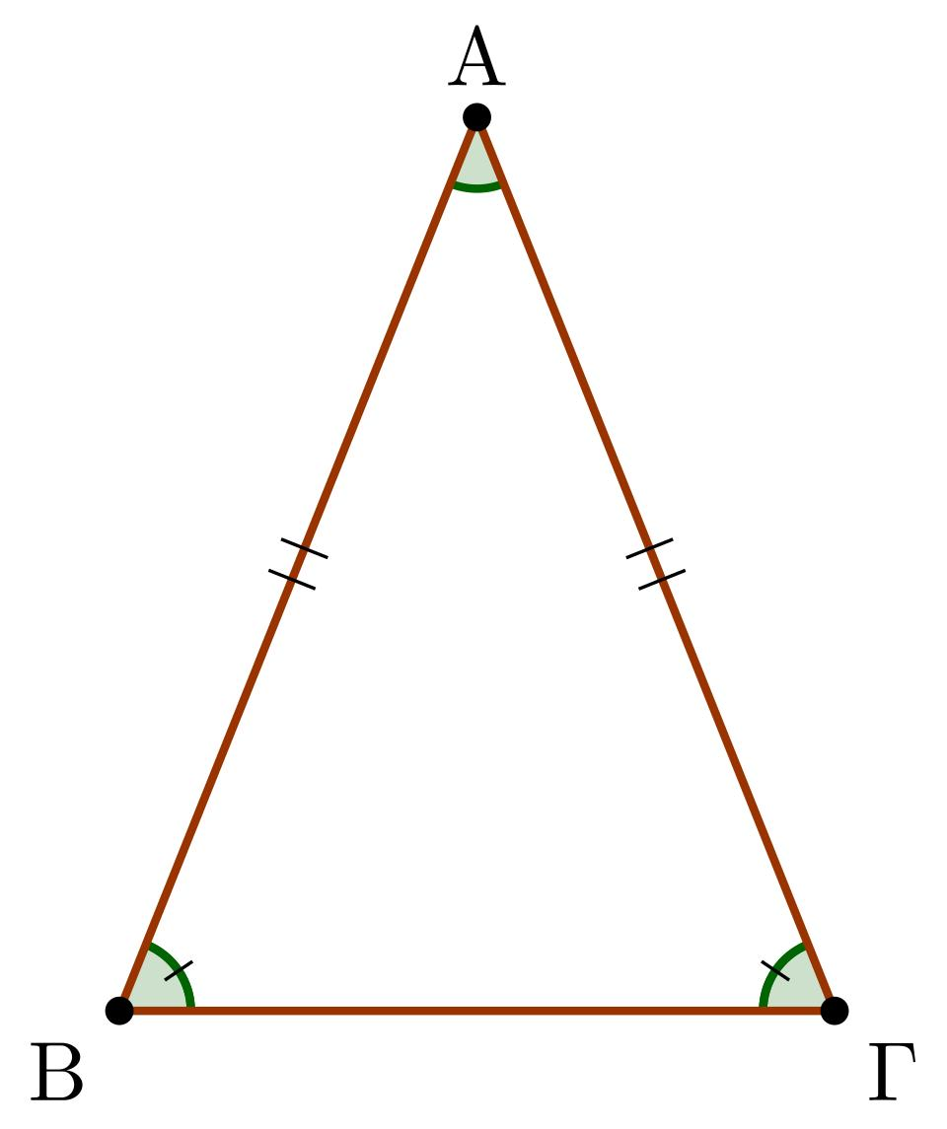
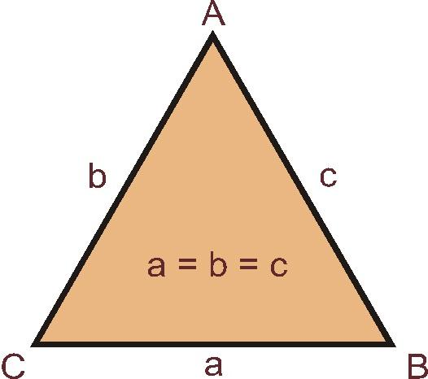
Certain triangles contain equal distances as defining properties.

1-Isosceles Triangle
# Source: AI Source: Provided by: [Data Path: Persons Table -> ID Column: 1, Name_En Column: Motasem Essam] -> From: [ChatGPT] on [7/25/2026]
An isosceles triangle has at least two equal sides:
$$\boxed{AB=AC}$$
Example
If:
$$AB=10\text{ cm}$$
then:
$$\boxed{AC=10\text{ cm}}$$

2-Equilateral Triangle
# Source: AI Source: Provided by: [Data Path: Persons Table -> ID Column: 1, Name_En Column: Motasem Essam] -> From: [ChatGPT] on [7/25/2026]
All three sides are equal:
$$\boxed{AB=BC=CA}$$
Example
If:
$$AB=8\text{ cm}$$
then:
$$\boxed{AB=BC=CA=8\text{ cm}}$$

Equality from Regular Figures
# Source: AI Source: Provided by: [Data Path: Persons Table -> ID Column: 1, Name_En Column: Motasem Essam] -> From: [ChatGPT] on [7/25/2026]
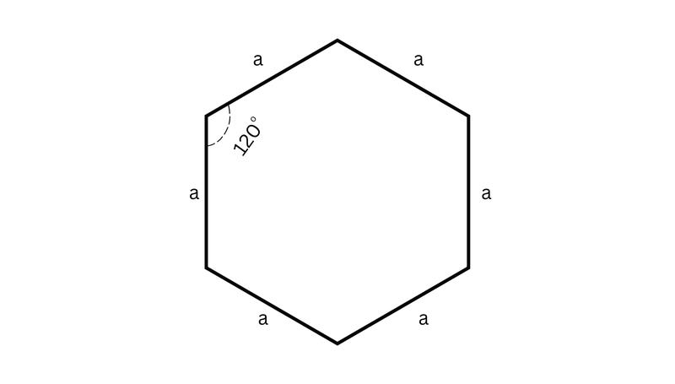
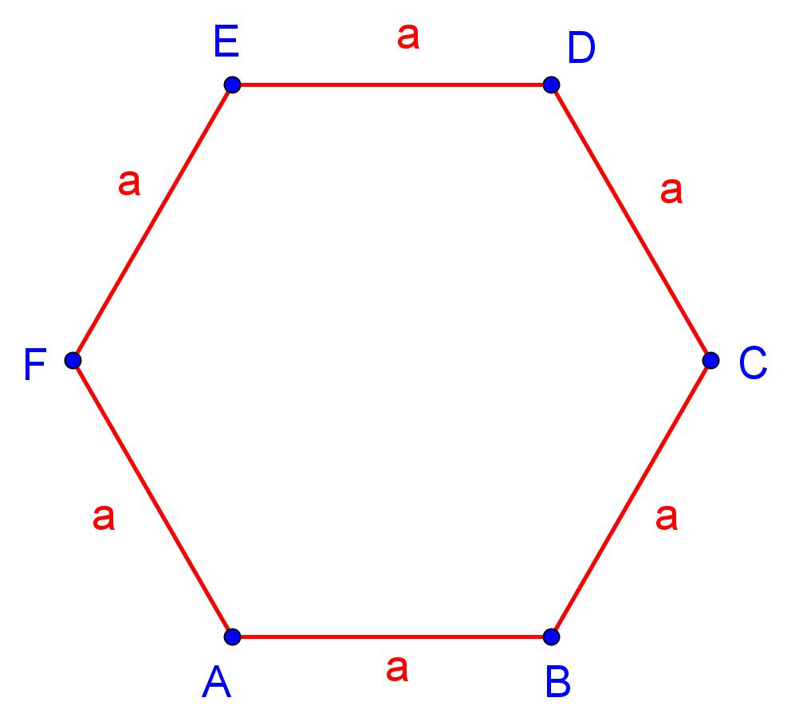
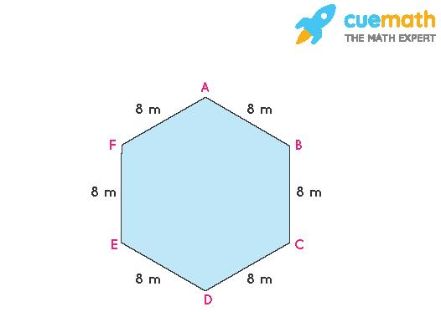
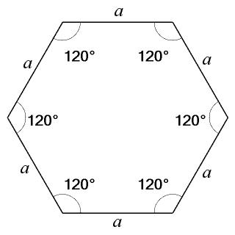
A regular polygon has all sides equal.
For a regular hexagon:
$$\boxed{AB=BC=CD=DE=EF=FA}$$
Example
If the side length is $4$cm:
$$\boxed{AB=BC=CD=DE=EF=FA=4\text{ cm}}$$

Equality from Coordinate Geometry
# Source: AI Source: Provided by: [Data Path: Persons Table -> ID Column: 1, Name_En Column: Motasem Essam] -> From: [ChatGPT] on [7/25/2026]
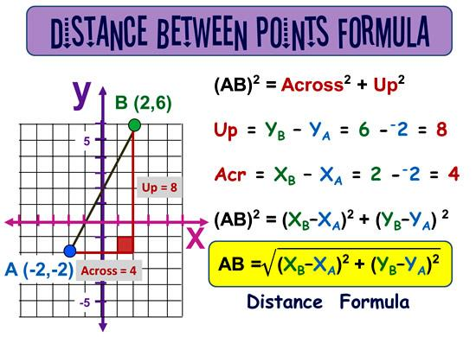
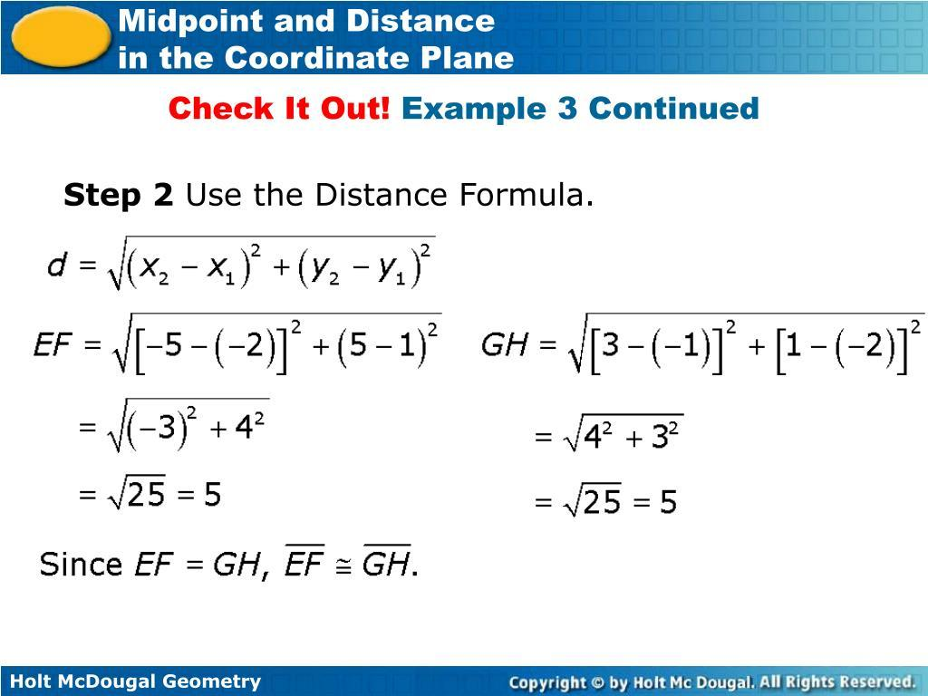
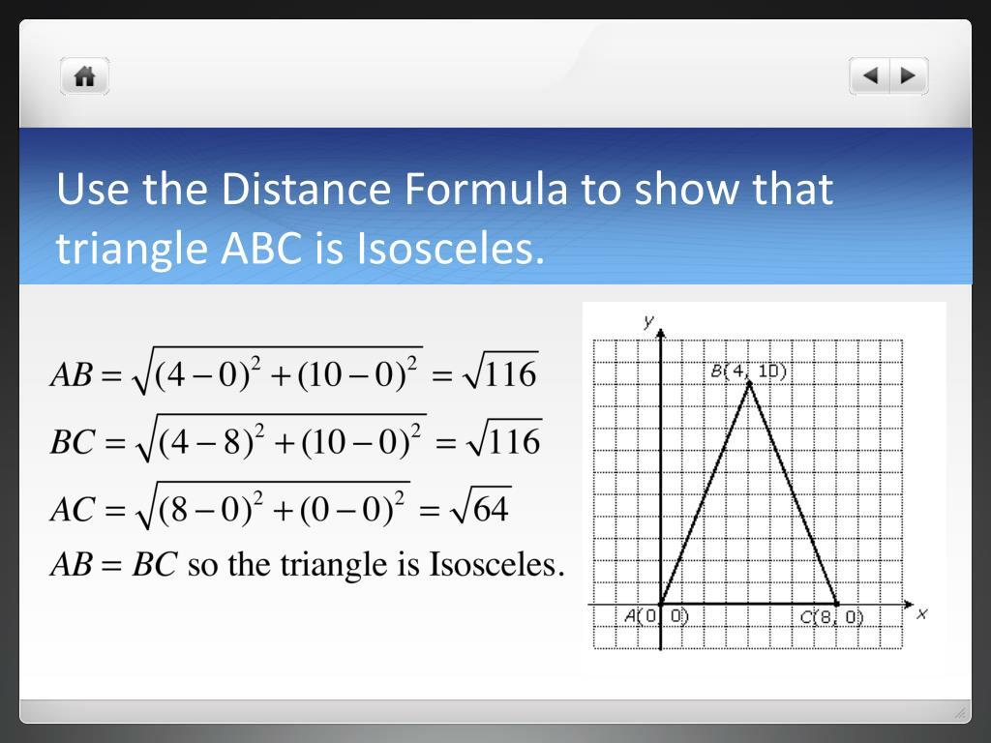
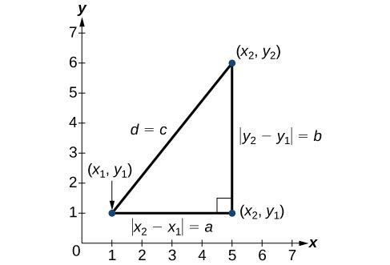
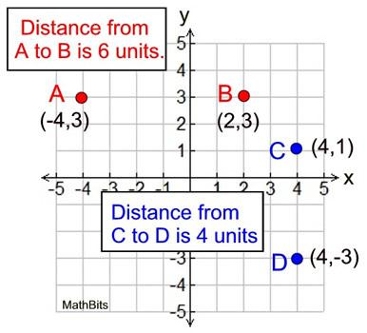
Distances can be calculated using coordinates.
For:
$$A\left(x_{1} , y_{1}\right)$$
and:
$$B\left(x_{2} , y_{2}\right)$$
the distance is:
$$\boxed{AB=\sqrt{{\left(x_{2}-x_{1}\right)}^{2}+{\left(y_{2}-y_{1}\right)}^{2}}}$$
Example
Let:
$$A=\left(0 , 0\right), B=\left(3 , 4\right)$$
Then:
$$AB=\sqrt{3^{2}+4^{2}} \\ AB=\sqrt{9+16} \\ \boxed{AB=5}$$
Now let:
$$C=\left(1 , 1\right), D=\left(4 , 5\right)$$
Then:
$$CD=\sqrt{{\left(4-1\right)}^{2}+{\left(5-1\right)}^{2}} \\ CD=\sqrt{3^{2}+4^{2}} \\ \boxed{CD=5}$$
Therefore:
$$\boxed{AB=CD=5}$$

Equality Established Algebraically
Distance equality can also be established by solving algebraic equations.
Example
Suppose:
$$AB=2x+4$$
and:
$$CD=3x-1$$
If:
$$AB=CD$$
then:
$$2x+4=3x-1 \\ x=5$$
Therefore:
$$AB=2\left(5\right)+4=14$$
and:
$$CD=3\left(5\right)-1=14$$
Thus:
$$\boxed{AB=CD=14}$$

Equality from the Pythagorean Theorem
# Source: AI Source: Provided by: [Data Path: Persons Table -> ID Column: 1, Name_En Column: Motasem Essam] -> From: [ChatGPT] on [7/25/2026]
Distance equality can sometimes be established by calculating two distances using the Pythagorean theorem.
For a right triangle:
$$\boxed{c^{2}=a^{2}+b^{2}}$$
Example
Suppose one distance is the hypotenuse of a $3$-$4$-$5$ triangle:
$$d_{1}=\sqrt{3^{2}+4^{2}}=5$$
Another distance is also:
$$d_{2}=\sqrt{3^{2}+4^{2}}=5$$
Therefore:
$$\boxed{d_{1}=d_{2}}$$

Equality of Distances from a Point to Lines
# Source: AI Source: Provided by: [Data Path: Persons Table -> ID Column: 1, Name_En Column: Motasem Essam] -> From: [ChatGPT] on [7/25/2026]
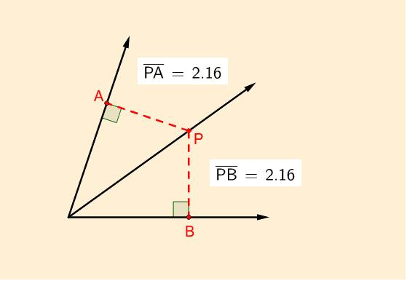
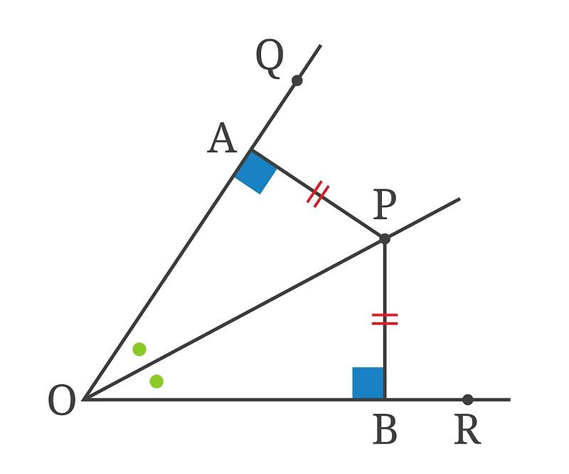
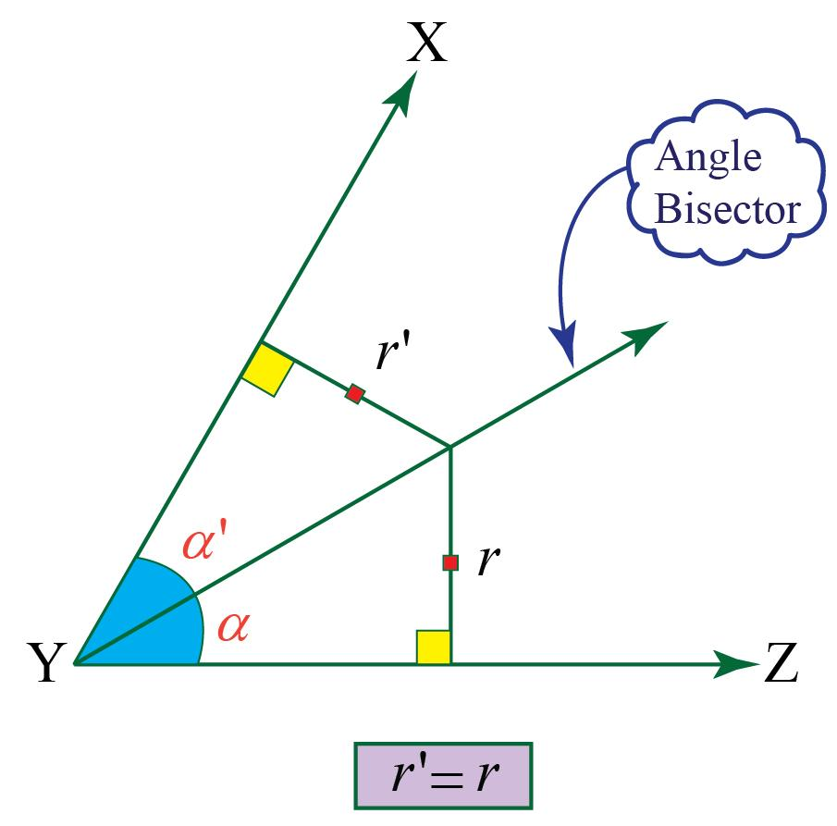
A point that is equally distant from two intersecting lines lies on one of their angle bisectors.
If:
$$d\left(P , l_{1}\right)=d\left(P , l_{2}\right)$$
then $P$lies on an angle bisector of the two lines.
Thus:
$$\boxed{d\left(P , l_{1}\right)=d\left(P , l_{2}\right) ⟺ P\text{ lies on an angle bisector}}$$
Example
If point $P$is $4$cm from each of two intersecting lines:
$$\boxed{d\left(P , l_{1}\right)=d\left(P , l_{2}\right)=4\text{ cm}}$$
then $P$lies on one of the angle bisectors.

Distance Equality in Geometric Proofs
# Source: AI Source: Provided by: [Data Path: Persons Table -> ID Column: 1, Name_En Column: Motasem Essam] -> From: [ChatGPT] on [7/25/2026]
Distance equality is frequently used as a statement in proofs.
Example
Given:
$M$is the midpoint of $AB$.
Prove:
$$AM=MB$$
Proof:
$$M\text{ is midpoint of }AB \\ ⇓$$
A midpoint divides a segment into two equal parts.
$$⇓ \\ \boxed{AM=MB}$$
That equality can then be used with other equalities to prove congruence.

Distance Equality vs Segment-Length Equality
# Source: AI Source: Provided by: [Data Path: Persons Table -> ID Column: 1, Name_En Column: Motasem Essam] -> From: [ChatGPT] on [7/25/2026]
These two concepts are closely related but have a useful distinction.
Segment-Length Equality
Usually emphasizes the lengths of line segments:
$$\boxed{AB=CD}$$
Distance Equality
Emphasizes the numerical distance between geometric objects:
$$\boxed{PA=PB}$$
or:
$$\boxed{d\left(P , l_{1}\right)=d\left(P , l_{2}\right)}$$
or:
$$\boxed{d\left(l_{1} , l_{2}\right)=d\left(l_{3} , l_{4}\right)}$$
Therefore:
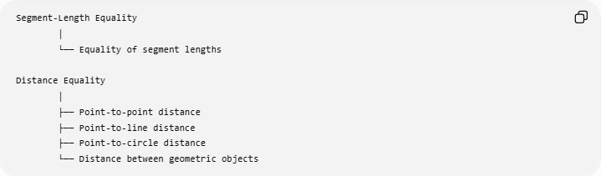
Segment-Length Equality
│
└── Equality of segment lengths

Distance Equality
│
├── Point-to-point distance
├── Point-to-line distance
├── Point-to-circle distance
└── Distance between geometric objects
There is significant overlap because a segment length is itself a distance.

Distance Equality vs Congruence
# Source: AI Source: Provided by: [Data Path: Persons Table -> ID Column: 1, Name_En Column: Motasem Essam] -> From: [ChatGPT] on [7/25/2026]
For two line segments:
$$\boxed{AB=CD}$$
means their lengths are equal.
Writing:
$$\boxed{\overset{‾}{AB}≅\overset{‾}{CD}}$$
means the two segments are congruent.
For line segments, these statements are equivalent in the usual Euclidean setting:
$$\boxed{\overset{‾}{AB}≅\overset{‾}{CD} ⟺ AB=CD}$$
But distance equality can also describe relationships that are not simply comparisons between two named segments.
For example:
$$\boxed{d\left(P , l_{1}\right)=d\left(P , l_{2}\right)}$$

Distance Equality vs Distance Inequality
# Source: AI Source: Provided by: [Data Path: Persons Table -> ID Column: 1, Name_En Column: Motasem Essam] -> From: [ChatGPT] on [7/25/2026]
Equality
$$\boxed{PA=PB}$$
Both distances are exactly the same.
Inequality
$$\boxed{PA>PB}$$
One distance is greater.
Approximation
$$\boxed{PA≈PB}$$
The distances are approximately equal, but not necessarily exactly equal.
Therefore:
$$\boxed{=≠>≠≈}$$

Important Distance-Equality Relationships
# Source: AI Source: Provided by: [Data Path: Persons Table -> ID Column: 1, Name_En Column: Motasem Essam] -> From: [ChatGPT] on [7/25/2026]
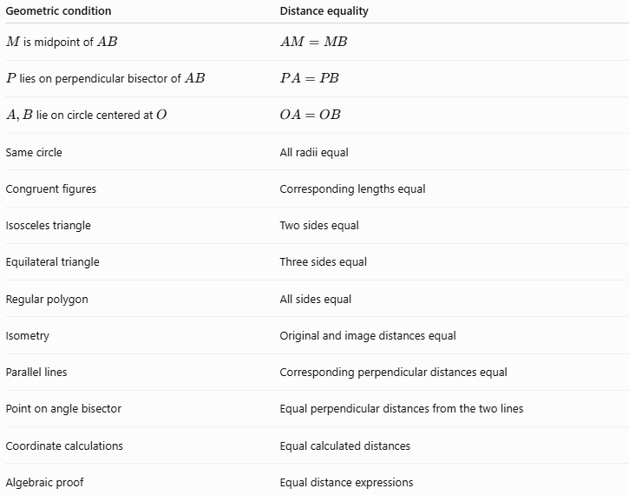
Geometric condition | Distance equality
$M$is midpoint of $AB$ | $$AM=MB$$
$P$lies on perpendicular bisector of $AB$ | $$PA=PB$$
$A,B$lie on circle centered at $O$ | $$OA=OB$$
Same circle | All radii equal
Congruent figures | Corresponding lengths equal
Isosceles triangle | Two sides equal
Equilateral triangle | Three sides equal
Regular polygon | All sides equal
Isometry | Original and image distances equal
Parallel lines | Corresponding perpendicular distances equal
Point on angle bisector | Equal perpendicular distances from the two lines
Coordinate calculations | Equal calculated distances
Algebraic proof | Equal distance expressions

Classification Summary
# Source: AI Source: Provided by: [Data Path: Persons Table -> ID Column: 1, Name_En Column: Motasem Essam] -> From: [ChatGPT] on [7/25/2026]
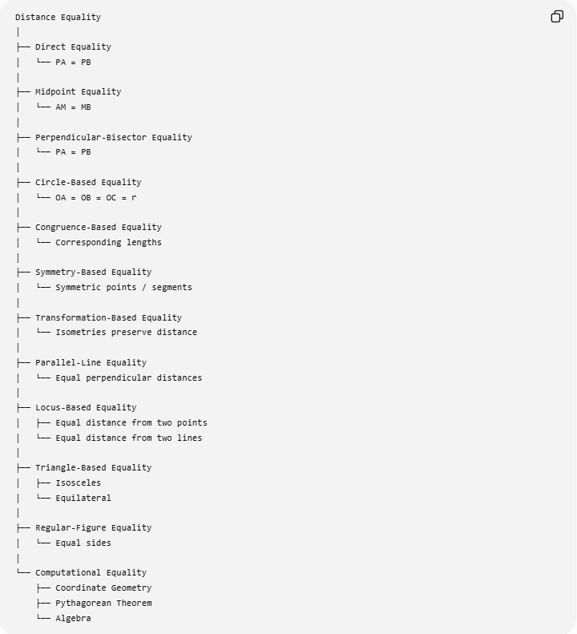
Distance Equality
│
├── Direct Equality
│ └── PA = PB
│
├── Midpoint Equality
│ └── AM = MB
│
├── Perpendicular-Bisector Equality
│ └── PA = PB
│
├── Circle-Based Equality
│ └── OA = OB = OC = r
│
├── Congruence-Based Equality
│ └── Corresponding lengths
│
├── Symmetry-Based Equality
│ └── Symmetric points / segments
│
├── Transformation-Based Equality
│ └── Isometries preserve distance
│
├── Parallel-Line Equality
│ └── Equal perpendicular distances
│
├── Locus-Based Equality
│ ├── Equal distance from two points
│ └── Equal distance from two lines
│
├── Triangle-Based Equality
│ ├── Isosceles
│ └── Equilateral
│
├── Regular-Figure Equality
│ └── Equal sides
│
└── Computational Equality
├── Coordinate Geometry
├── Pythagorean Theorem
└── Algebra

Relationship to Geometric Equality
# Source: AI Source: Provided by: [Data Path: Persons Table -> ID Column: 1, Name_En Column: Motasem Essam] -> From: [ChatGPT] on [7/25/2026]
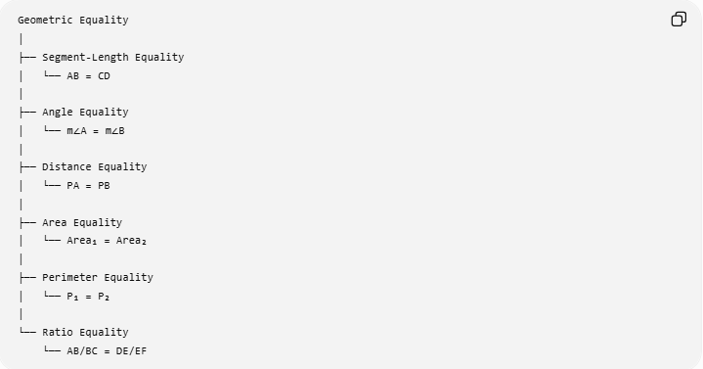
Geometric Equality
│
├── Segment-Length Equality
│ └── AB = CD
│
├── Angle Equality
│ └── m∠A = m∠B
│
├── Distance Equality
│ └── PA = PB
│
├── Area Equality
│ └── Area₁ = Area₂
│
├── Perimeter Equality
│ └── P₁ = P₂
│
└── Ratio Equality
└── AB/BC = DE/EF
Distance Equality is therefore one of the major forms of Geometric Equality.

Key Formulas
# Source: AI Source: Provided by: [Data Path: Persons Table -> ID Column: 1, Name_En Column: Motasem Essam] -> From: [ChatGPT] on [7/25/2026]
Point-to-Point Distance
$$\boxed{AB=\sqrt{{\left(x_{2}-x_{1}\right)}^{2}+{\left(y_{2}-y_{1}\right)}^{2}}}$$
Midpoint
$$\boxed{AM=MB}$$
Perpendicular Bisector
$$\boxed{PA=PB}$$
Circle Radius
$$\boxed{OA=OB=OC=r}$$
Point Equidistant from Two Lines
$$\boxed{d\left(P , l_{1}\right)=d\left(P , l_{2}\right)}$$
Parallel Lines
$$\boxed{d_{⊥}\left(l_{1} , l_{2}\right)=\text{constant}}$$
Isosceles Triangle
$$\boxed{AB=AC}$$
Equilateral Triangle
$$\boxed{AB=BC=CA}$$

Key Points
# Source: AI Source: Provided by: [Data Path: Persons Table -> ID Column: 1, Name_En Column: Motasem Essam] -> From: [ChatGPT] on [7/25/2026]
- Distance Equality means two or more geometric distances are exactly equal.
- Its basic form is:
$$\boxed{PA=PB}$$
- A midpoint creates equal distances from the midpoint to the endpoints.
- A point on a perpendicular bisector is equally distant from the segment's endpoints.
- Every radius of the same circle is equal.
- Congruent figures have equal corresponding distances.
- Isometries preserve distances.
- Parallel lines have equal perpendicular distances between them.
- A point equidistant from two intersecting lines lies on an angle bisector.
- Isosceles and equilateral triangles provide important examples of distance equality.
- Regular polygons have equal side lengths.
- Coordinate geometry and algebra can establish distance equality computationally.
- Distance equality is closely related to Segment-Length Equality, but it can also describe point-to-line and other geometric distances.

Conclusion
# Source: AI Source: Provided by: [Data Path: Persons Table -> ID Column: 1, Name_En Column: Motasem Essam] -> From: [ChatGPT] on [7/25/2026]
Distance Equality is the exact equality of distances between geometric objects. It appears naturally in midpoints, perpendicular bisectors, circles, congruent figures, symmetry, isometries, parallel lines, loci, triangles, regular polygons, and coordinate geometry.
Its central idea can be summarized as:
$$\boxed{\text{Equal Distance}=\text{Same Exact Geometric Measurement}}$$

